Nicholas Jones, Mathew Bobbitt 

*SYS255 Final*

Professor Eastman

12/12/21

WordPress Deployed on NGINX Web Server

**Description:**

As a team we will be deploying WordPress on a NGINX web server hosted on an Ubuntu Linux box. This will include the installation of Mariadb, PHP, and NGINX itself, allowing for the editing and posting of wordpress blogs on a local ubuntu vm.

**Overview:**

* How to install and configure NGINX web server on sn ubuntu linux box
* How to deploy and configure Wordpress CMS on NGINX ubuntu server
* How to customize and configure personal WordPress website

**References:**

<https://www.tecmint.com/install-wordpress-with-nginx-in-ubuntu-20-04/>

**Build Documentation:**

*Pre-Requisites:*

* Configured and running Ubuntu v20.04 or later

Install nginx:

sudo apt install nginx

sudo apt install mariadb-server

Sudo service mysql start

sudo mysql_secure_installation and fill out prompts as shown below

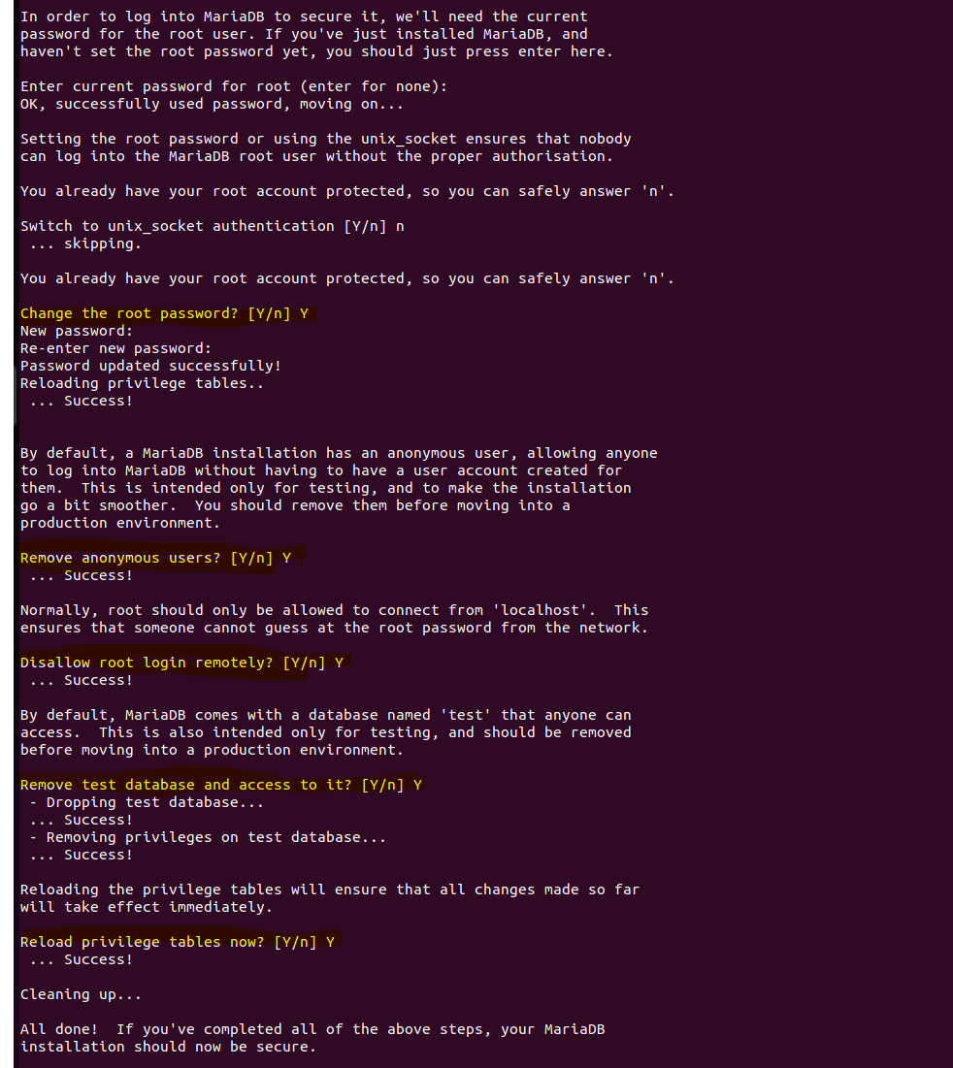

sudo mysql -u root -p (Log into MariaDB to create database)

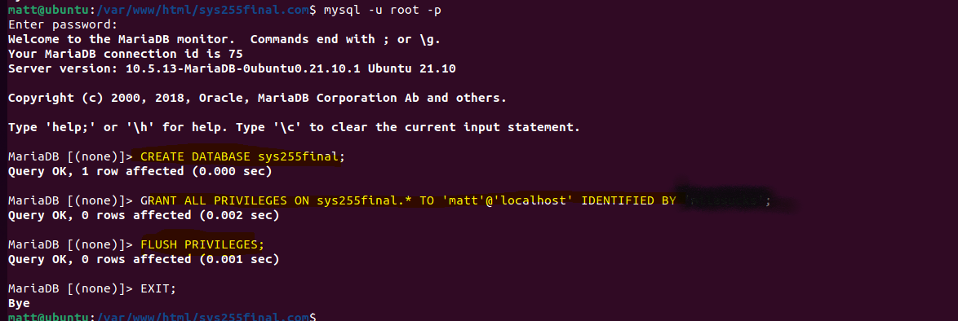

Download and install PHP:

sudo add-apt-repository ppa:ondrej/php

sudo apt update

sudo apt install php7.2-cli php7.2-fpm php7.2-mysql php7.2-json php7.2-opcache php7.2-mbstring php7.2-xml php7.2-gd php7.2-curl

Do a systemctl status php* and look for php8.0-fpm to verify php is running

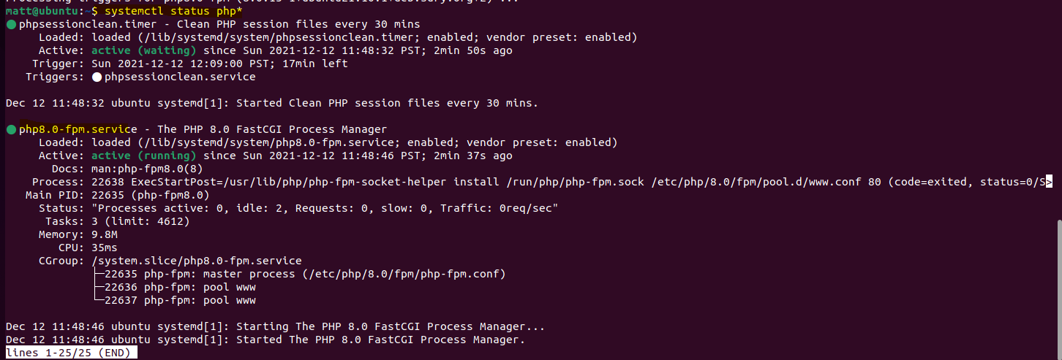

sudo nano /etc/php/8.0/fpm/php.init (Add Configure Settings as shown)

file_uploads = On

allow_url_fopen = On

short_open_tag = On

memory_limit = 256M

cgi.fix_pathinfo = 0

upload_max_filesize = 100M

max_execution_time = 360

date.timezone = US/Eastern

Create a directory to store information regarding your website and html

sudo mkdir -p /var/www/html/yourwebsitename.com



From the official WordPress website, you can download the latest WordPress installs. Download it to the /tmp directory. You can access said directory by using **cd**, and download the archive using **wget:**

cd /tmp

wget <https://wordpress.org/latest.tar.gz>

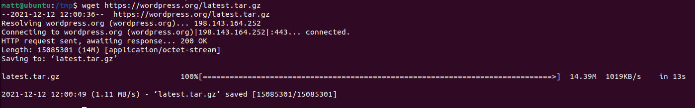

Next, you can extract this archive to the directory created earlier. This can be done using:

tar xf latest.tar.gz

sudo mv /tmp/wordpress/* /var/www/html/yourwebsitename.com/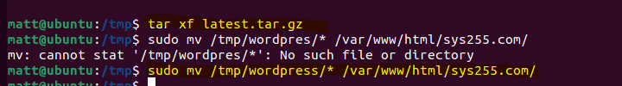

The web server will require complete access to these files. Change the permission using:

sudo chown -R www-data: /var/www/html/yourwebsitename.com/

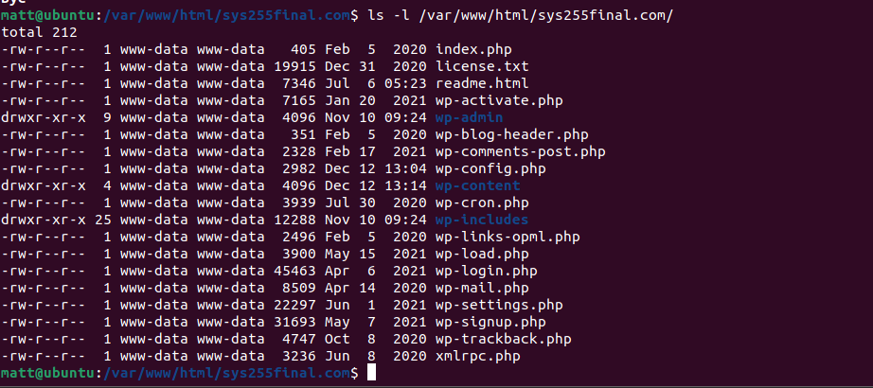

sudo systemctl restart nginx

Create new file in /etc/nginx/conf.d/yoursitename.com.conf

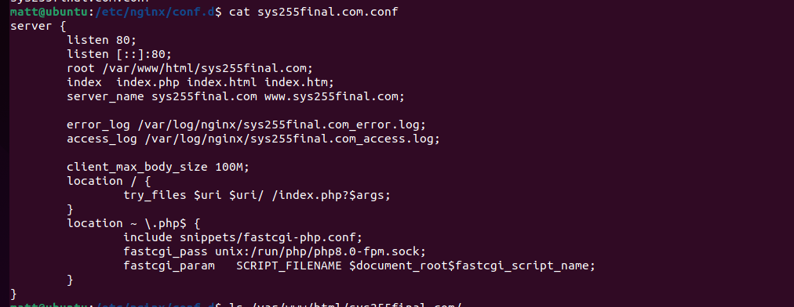

Enter the /var/www/html/yourwebsitename directory

cp wp-config-sample.php wp-config.php

Add Correct database details into newly copied wp-config.php

(the name of the database for WordPress, MariaDB database username, and the user’s password)

Vi wp-config.php

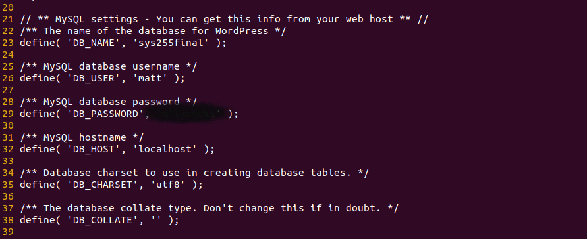

Try To go to your loopback site 127.0.0.1

Configuring WP in the web Installer:

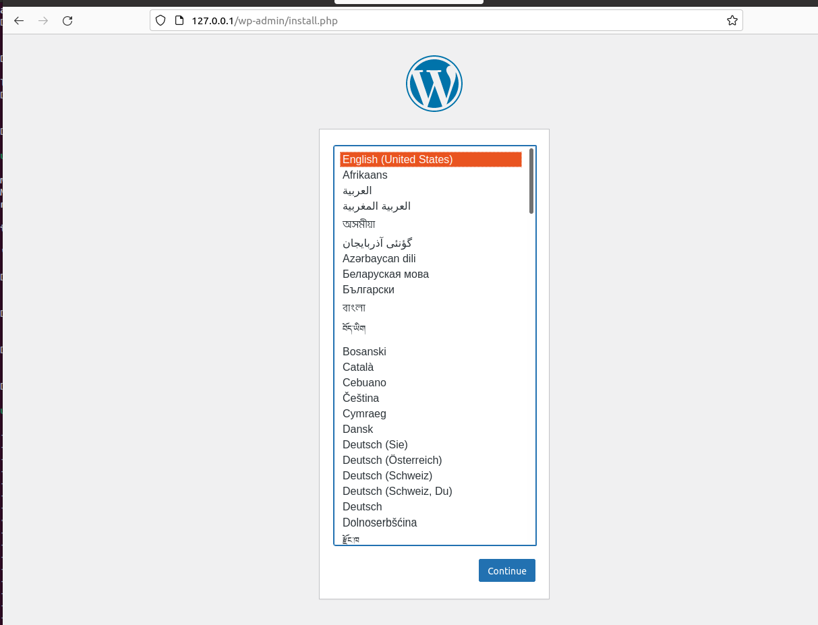

Enter desired login details and then login to WP

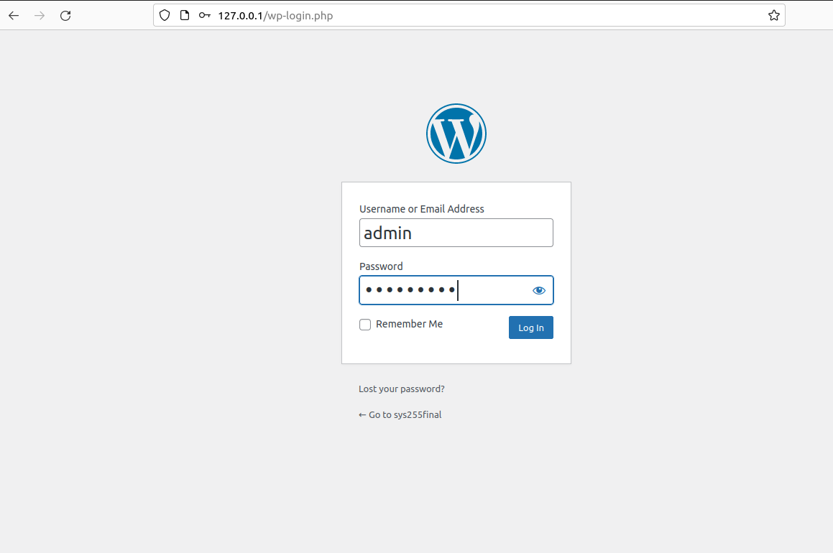

Customize your WP website, make posts, explore, and comment all using the wordpress web gui.

**Test Script:**

1. Create WordPress database for your website
2. Create a configuration file for WordPress
3. Modify and configure database connection settings
4. Create an NGINX virtual host/server block for your website
5. Complete WordPress installation using the WP web installer and log in
6. Customize personal website via the WP admin dashboard

**Video:** Recorded on Loom

[**Configuration Demo**](https://www.loom.com/share/0e3fa57a25944a8c9d4cf0a49409dc64)

* This example assumes the user has installed NGINX, MariaDB, and the latest version of PHP.

**Discussion**

* This project was not easy persay; it was hard to find a topic that we could complete with our given knowledge/resources on campus.
* Information research was quite easy to find on this topic as WP is well known
* Messing around with the configurations when things didn't go as outlined in articles was difficult, as we were going off our own knowledge instead of existing research.
* The process of recording the demo proved difficult as the default software in Ubuntu did not play nice, however with enough massaging, we were able to find the correct configurations.
* Getting good documentation on nginx and wordpress also was sort of challenging at first.